*After setting up Linux (Amazon Linux, Ubuntu, CentOS, RHEL, etc.) running ec2 Instance on AWS cloud computing platform we can use SSH to connect and control it remotely; instead of using the console directly from ec2 Dashboard.*

SSH is a secure shell protocol that default uses port number 22 to connect remote systems. To use it, the remote system must be running on SSH servers such as OpenSSH, then only any client machine will be able to connect remotely.

Well, the Linux OS running on Ec2 instances come with a pre-installed OpenSSH server. Hence, we just need to generate an SSH key pair or private that will help us to log in it remotely but securely.

**Generate SSH to connect AWS ec2 Linux Instances**

**1. log in to AWS**

First of all, go to the AWS login page to access all the cloud services offered by it.

**2. Go to ec2 Dashboard**

Once you log in to your AWS account you will see the AWS Management Console. On the left top side, click on the **Service** drop Menu to select **EC2**.

[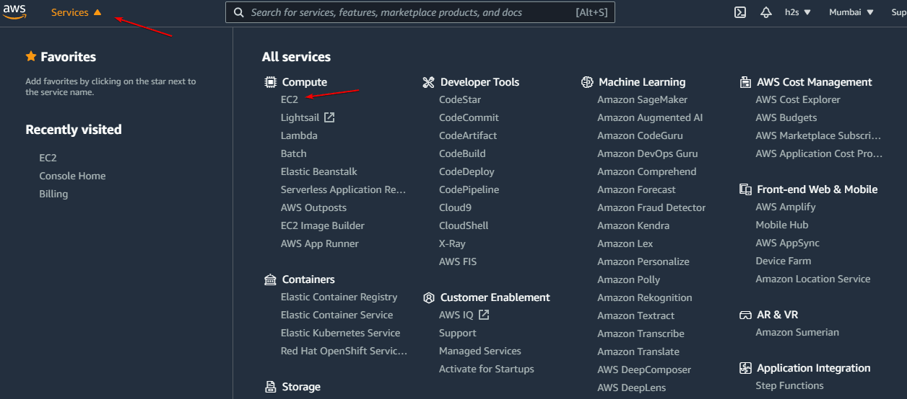](https://www.how2shout.com/linux/wp-content/uploads/2021/08/Login-to-Ec2-AWS-account.png)

**2. Create a New Amazon ec2 Instance (optional)**

If you already have a running ec2 Instance then for sure you have the Private key already with you. Hence, move to the next step. Whereas, users who are new to AWC Ec2, need to first create an “Instance”.

**3. Go to your Instance**

Now, from the left side panel, select the **Instances** option. And click on the **Instance ID** that you want to connect over **SSH remotely**.

Also, **note** **down** the**Public Ip-address** attached to your Instance because we need it to connect and access the same remotely over SSH.

**Note**: Well, if you don’t have any running instances then create a new one using the “**Launch Instances**” button given on the top right side.

[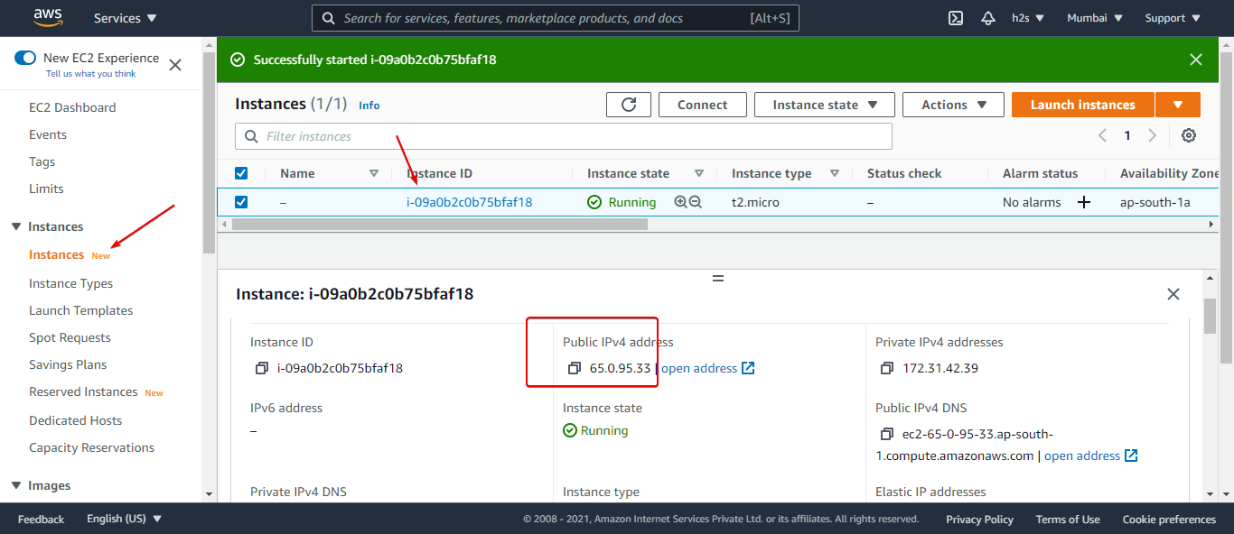](https://www.how2shout.com/linux/wp-content/uploads/2021/08/Copy-AWS-Instance-Public-Ip-address.png)

**6. Connect to ec2 Instance over SSH**

To connect your Linux or Windows AWS ec2 instance over SSH you can either use some dedicated SSH client application such as **Putty** or **MobaXterm**. Alternatively, just open your Windows or Linux PC command terminal and **ssh** your remote machine using the steps given here.

**Using Putty**

If you are a **Putty** user on Windows, then here are the steps to follow.

**1: PuTTy Key Generator- Load an existing private-key file**

Go to the **Windows 10/11** start menu and search **PuTTYGen**. Once it appears, click on the **Load** button.

[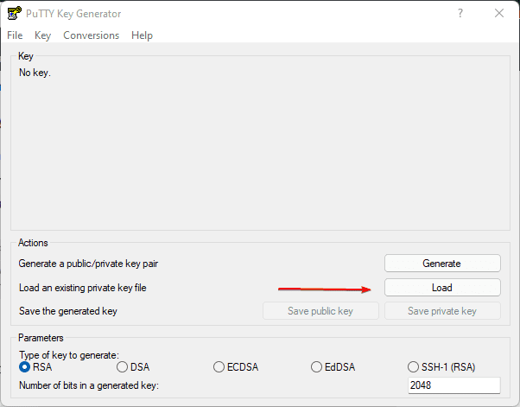](https://www.how2shout.com/linux/wp-content/uploads/2021/08/Load-an-exisitng-Private-key-filwe.png)

**2: Open Pem Key**

Click on the **drop-down** box and select “**All Files**“; after that navigate to the place where you have saved your downloaded **Ec2 instance** Private key in PEM format and select it to open.

[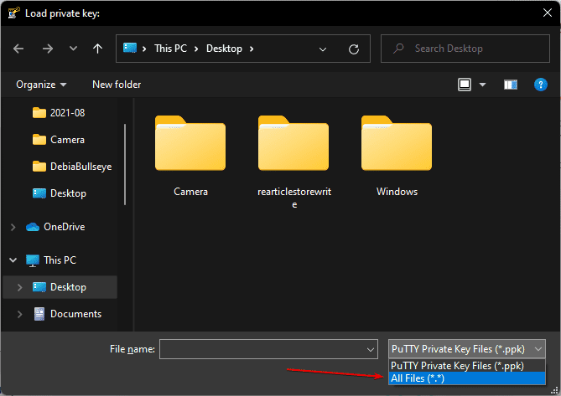](https://www.how2shout.com/linux/wp-content/uploads/2021/08/Save-PPK-key.png)

**3: Convert and Save PEM to PPK key**

Now, Click on the “**Save Private Key**”  button and then click on the “**Yes**“. Give some name to your newly generated **PPK** key and **save** it on your system.

[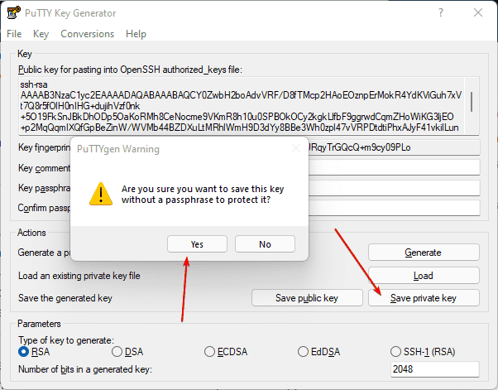](https://www.how2shout.com/linux/wp-content/uploads/2021/08/Convert-.PEM-key-to-.PPk-private-key.png)

**4. Configure Putty HostName**

Under Session, go to the **Host Name** box and **type** – ec2-user@publc-ipaddress. **Replace** public-ipaddress with the address of your ec2 instance that you want to connect over SSH.

After that click on the “**Save**” button.

[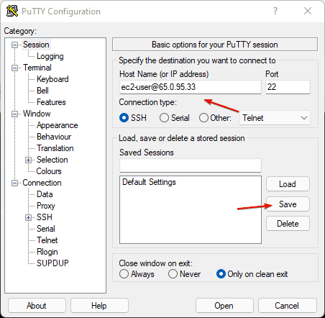](https://www.how2shout.com/linux/wp-content/uploads/2021/08/Putty-settings-SSH-for-Ec2.png)

**5. SSH Authentication**

Now, go to **Auth** from the Putty’s **Category** section, click on the **Browse** button to select the newly generated**.PPK** key that you saved in the 3rd step.

After that click on the “**Open**” button.

[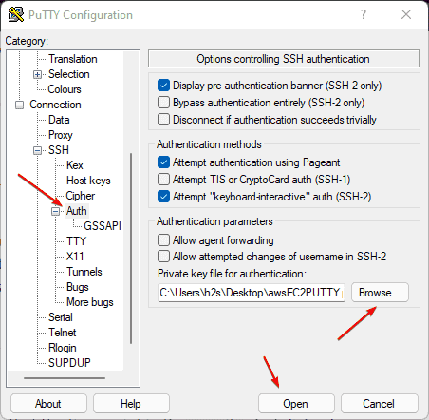](https://www.how2shout.com/linux/wp-content/uploads/2021/08/Add-PPK-to-Putty-for-AWS-Instance-.png)

**6. Login**

Finally, you will have a Security warning – with two options “**Accept**” and **Connect Once**“. For security, if you are using some PC that is not yours then select “**Connect Once**“. Whereas on your personal system and if you don’t want to add key again and again, then simply select “**Accept**” to let Putty store Server’s host key in the cache.

[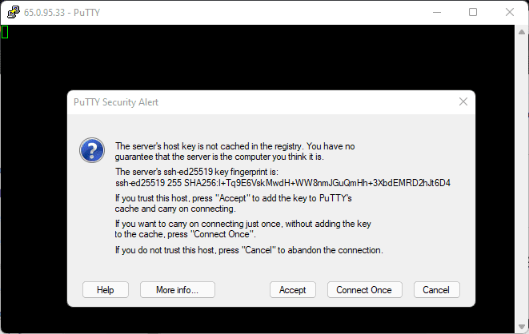](https://www.how2shout.com/linux/wp-content/uploads/2021/08/Putty-Security-Alert.png)

[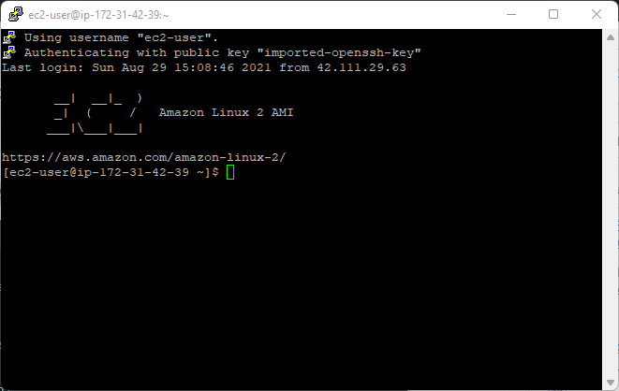](https://www.how2shout.com/linux/wp-content/uploads/2021/08/Use-putty-command-terminal-to-access-ec2-AWS-instance.png)